-
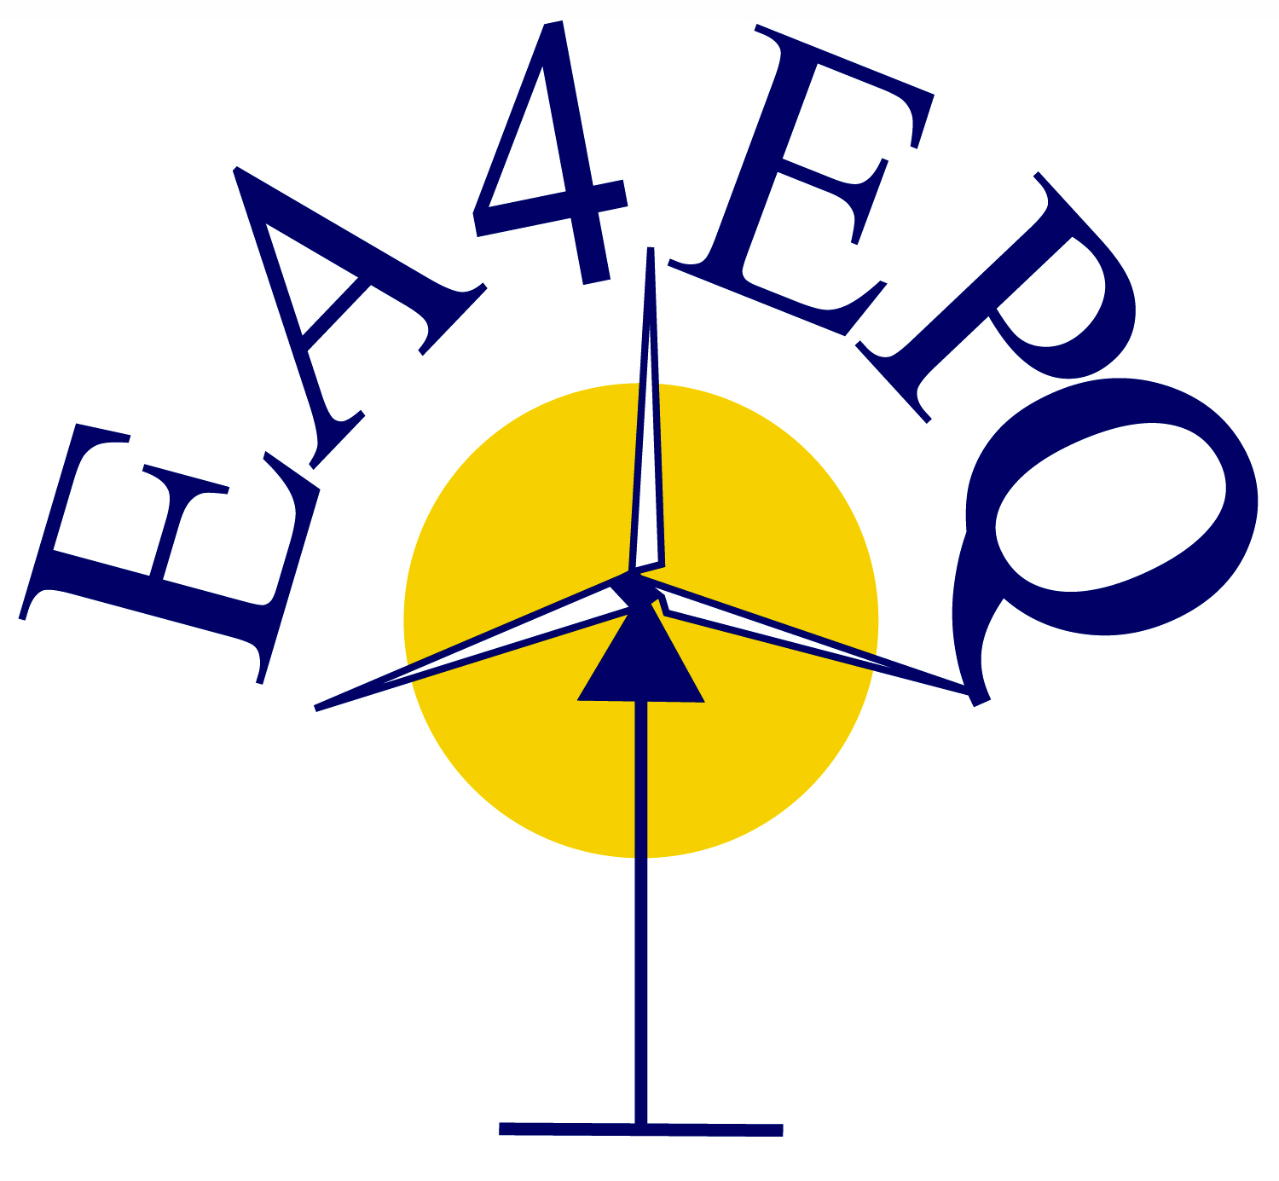
European Association for the
Development of Renewable Energies,
Environment and Power Quality

RESERVATION FORM
(It is necessary to fill out and send this form before July 10)

Name:

I want to participate, free of charge, in the activities marked with an (X)
(Only for speakers of keynotes in the ICREPQ’22 conference)

ACTIVITY | SELECT(X)
Civic Reception (Ciudad de Vigo Hotel), on July 27, at 21:00 H
Conference Dinner (Parador de Baiona), on July 28, at 20:30 H
Cultural Visit to Vigo, on July 27, from 18:30 H to 21:00 H
Cultural Visit to Baiona, on July 28, from 18:30 H to 21:00 H
Cultural Visit to Santiago, on July 29, from 15:00 H to 21:00 H
NOTE: The departure of the buses will be from the School of Industrial Engineering on the Campus

Signature

You can send us this form at the following electronic address secretariat@icrepq.com. You will receive a message about the reception of your e-mail.

